ASSIGNMENT 1
- What is data enrichment and consolidation?

Data enrichment refers to the process of enhancing or improving raw data by adding relevant, additional information from external or internal sources.
- What is architectural view?

An IoT architecture view refers to the overall design or framework that outlines how different components of an IoT system interact with each other to collect, process, and share data. It typically involves multiple layers, each responsible for a specific function in the system.

Eg:- 4 Stage IOT Architeture.

- What are some of the main differences between the following:
  - Arduino and raspberry Pi
Arduino | Raspberry Pi
Low processing power (8-bit microcontroller) | High processing power (ARM processor, runs full OS)
Limited RAM (2 KB to 256 KB) | Higher RAM (512 MB to 8 GB depending on model)
Basic connectivity (USB, UART, SPI, I2C) | Built-in Wi-Fi, Bluetooth, Ethernet, USB ports
Low power consumption (USB or battery) | Higher power consumption (USB or adapter)

  - Sensors and actuators

Sensors | Actuators
Converts physical events or characteristics into electrical signals. | Converts electrical signals into physical events or characteristics.
Used to collect data from the environment. | Used to perform actions based on data.
Example: Thermometer (temperature to electrical signal). | Example: Motor (electrical signal to mechanical motion).
Plays a key role in IoT for monitoring, managing, and controlling environments. | Acts upon the environment based on sensor data.

  - Zigbee and 6LOWPAN

ZigBee | 6LoWPAN
Low power consumption: Ideal for battery-powered devices. | Low power consumption: Designed for low-power, small devices with minimal processing.
Mesh networking: Supports mesh networking to extend range. | IPv6 connectivity: Ensures even low-power devices can connect via IPv6.
Data rate: Maximum of 250 kbps, limited for high-bandwidth applications. | Data rate: Maximum of 200 kbps, suitable for low-bandwidth IoT devices.
Range: Typically 10-100 meters. | Range: Outdoor range up to 200 meters.

  - NFC and RFID

NFC | RFID
Short range (0-5 cm): Used for secure, close-range interactions like mobile payments. | Longer range: Can communicate from a few centimeters to several meters, ideal for asset tracking.
Low data transfer speed: Limited for simple data exchanges like payments and access control. | Higher data transfer speed: Suitable for tracking large volumes of items or personnel.
Powered by reader (passive tags): Requires the reader to power NFC tags. | Active and passive tags: Can be powered by the tag itself (active) or by the reader (passive).
Common in mobile devices: Widely used in smartphones for contactless payments, access control, and data sharing. | Used for tracking: Common in logistics, inventory management, healthcare, and transportation systems.

  - IPV4 and IPV6

IPv4 | IPv6
32-bit address: Allows for about 4.3 billion unique addresses. | 128-bit address: Provides an almost unlimited number of unique addresses (around 340 undecillion).
Limited address space: IPv4 address exhaustion is a concern. | Vast address space: Designed to handle the growing number of devices in IoT and beyond.
Uses dotted-decimal notation: Represented in four sets of numbers (e.g., 192.168.0.1). | Uses hexadecimal notation: Represented in eight groups of four hexadecimal digits (e.g., 2001:0db8:85a3:0000:0000:8a2e:0370:7334).
No built-in security: Security features like IPsec are optional. | Built-in security: Designed with IPsec (encryption and authentication) as a mandatory feature for secure communications.

4. Explain IOT application layer protocols : HTTP, CoAP and MQTT.
- HTTP (Hypertext Transfer Protocol): A widely used application layer protocol for transferring web data, but less efficient for IoT due to high overhead and resource consumption.
- CoAP (Constrained Application Protocol): A lightweight protocol designed for low-power, low-bandwidth IoT devices, providing efficient communication in constrained networks.
- MQTT (Message Queuing Telemetry Transport): A publish/subscribe messaging protocol optimized for lightweight communication, ideal for real-time IoT applications with low bandwidth and intermittent connectivity.

5. Explain an embedded system on an IoT device.
It is a combination of hardware and software used to perform special tasks. It includes microcontroller and microprocessor memory, networking units (Ethernet Wi-Fi adapters), input output units (display keyword etc. ) and storage devices (flash memory). It collects the data and sends it to the internet. Embedded systems used in Examples –
1. Digital camera 2. DVD player, music player 3. Industrial robots
4. Wireless Routers etc.
6. What is M2M communication? Justify the statement with an illustrative scenario: "IoT is much more than M2M communication".
The process of exchanging information or messages between two or more machines or devices is known as Machine to Machine (M2M) communication.
IoT uses the basic concepts of M2M and expands by creating large “cloud” networks of devices that communicate with one another through cloud networking platforms.
Scenario: Smart Home System
In a basic M2M setup, a smart thermostat may communicate directly with a smart air conditioning unit to adjust the temperature. In an IoT-enabled smart home, the same smart thermostat not only communicates with the air conditioning unit (M2M) but also connects to a cloud server that stores data and analyzes patterns over time. The system can automatically adjust the temperature based on the user's preferences, the time of day, or external factors like weather.
7. Describe the design principles for connected devices
• Interoperability: Devices must be able to communicate and work together, regardless of manufacturer or platform.
• Security: Protect data integrity and privacy from unauthorized access or breaches.
• Scalability: Systems should be able to grow and manage increased demand.
• Reliability: Devices should function consistently and accurately over time.
• Energy Efficiency: Minimize power consumption to extend the battery life of devices.
8. Explain Modified OSI Stack for the IoT/M2M Systems.
The following figure shows a classical seven-layer OSI model (on the left) and the modifications in that model proposed by IETF(in the middle).
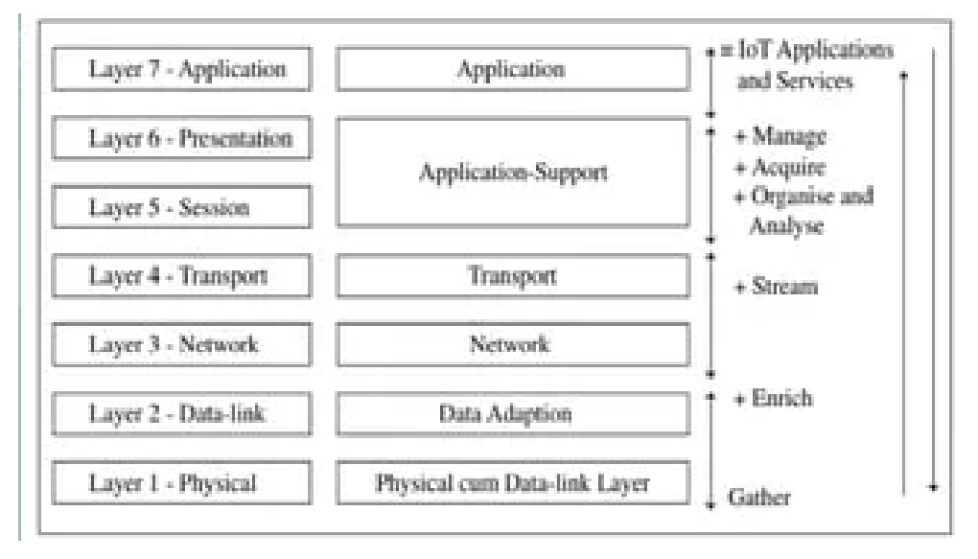

Application layer L6:New applications and services are present at the application layer 6
Application-support layer L5:A modification to the OSI is that the applicationsupport layer 5, it uses CoAP protocol for network communication
Transport layer L4:The transport layer does device identity management, identity registry and data routing to the next layer.
Network Layer L3:It communicates a network stream on the Internet to the next layer.
Data-adaptation layer L2: The data adaptation layer includes a gateway. The gateway enables communication between the devices network and the web.
Physical cum data-link layer L1: It senses the data and transferring the sensed data to L2. A physical IoT/M2M device hardware may integrate a wireless transceiver using a communication protocol
9. Justify the role of IoT in Smart Home applications in detail by choosing appropriate case study.

Case Study: The Nest Thermostat (Smart Climate Control)
One of the most prominent examples of IoT in smart homes is the Nest Thermostat, developed by Nest Labs, which was acquired by Google. The Nest Thermostat is an intelligent, Wi-Fi-enabled device that allows homeowners to remotely control their heating and cooling systems via smartphones, tablets, or computers.
In the case of the Nest Thermostat, IoT is used to create a smart, energy-efficient, and user-friendly climate control system that improves the overall quality of life for users. The integration of IoT into smart home devices like thermostats leads to automation, data-driven decisions, remote monitoring, and better energy management.
This case study highlights how IoT technologies enable smart homes to not only provide comfort but also enhance security, improve energy efficiency, and give users greater control over their living
10. What is the purpose of using UART in microcontroller communications, and how does it differ from SPI and I2C.
UART stands for Universal Asynchronous Receiver Transmitter. UART converts data into serial data. though, UARTs communicate directly by converting data into serial form and transmits it into the receiving UART that converts serial data into parallel data for the receiving device.
UART Differ from SPI and I2C in following ways:-
- UART is asynchronous and only allows for point-to-point communication.
- UART only requires two wires (Tx and Rx), making it simple but limited.
- UART generally operates at lower speeds (up to 115 kbps)
- UART is designed for communication between two devices (point-to-point)

11. Write an Arduino program to motion sensing LED bulb. Also list and explain the different components required.
Components Required:
- Arduino Board (e.g., Arduino Uno)
- PIR Motion Sensor
- Relay Module
- LED Bulb
- Jumper Wires
- Breadboard
const int mSP = 8;
const int rP = 7;
int mS = 0;

void setup() {
pinMode(mSP, INPUT);
pinMode(rP, OUTPUT);
digitalWrite(rP, LOW);
}

void loop() {
mS = digitalRead(mSP);
if (mS == HIGH) digitalWrite(rP, HIGH);
else digitalWrite(rP, LOW);
delay(500);
}
12. What are the typical ranges and applications of wireless technologies like WiFi, Bluetooth and Zigbee in IOT?

WiFi:
- Range: 30-100 meters
- Applications:
  - Smart Home: Connecting smart devices like lights and thermostats.
  - Healthcare: Remote health monitoring systems.

Bluetooth:
- Range: 10-100 meters
- Applications:
  - Wearables: Fitness trackers and smartwatches.
  - Smart Home: Smart locks and speakers.

Zigbee:
- Range: 10-100 meters (extended with mesh network)
- Applications:
  - Home Automation: Smart lighting and thermostats.
  - Industrial IoT: Factory sensors and asset tracking.
13. What are the advantages in using Arduino over other microcontroller platforms?
Ease of Use: Arduino is designed to be beginner-friendly with a simple programming environment (Arduino IDE) and an intuitive setup.
Low Cost: Arduino boards are affordable, making it a cost-effective choice for DIY projects and prototyping.
Open-Source: Both hardware and software are open-source, meaning that anyone can use, modify, and contribute to the Arduino platform.
Extensive Libraries and Resources: The Arduino ecosystem is rich with libraries, tutorials, and example codes that simplify the development process.

